Passage2
CHEMISTRY

Chemists are reimagining recycling to keep plastics out of landfills

Too much of today's plastic is impossible to recycle
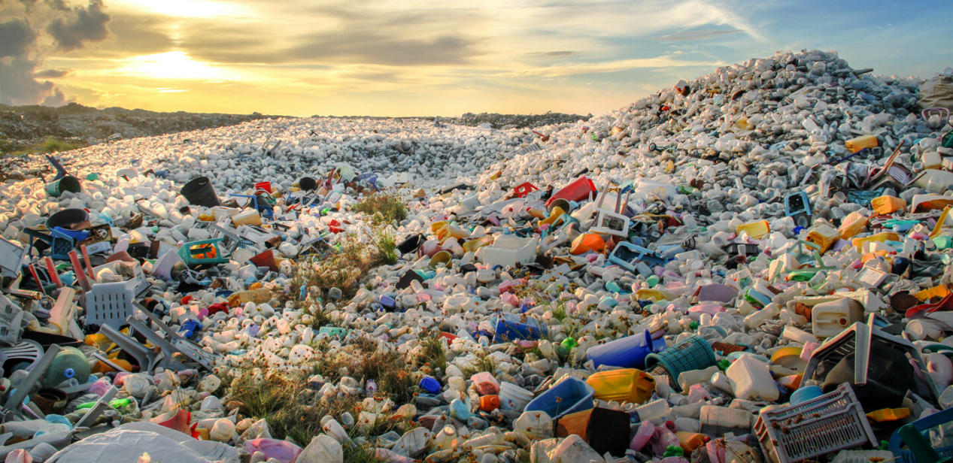
A lot of plastic goes to landfills because the material is too difficult to recycle into useful new products.
ABDUL RAHEEM MOHAMED/EYEEM/GETTY IMAGES
By Maria Temming
JANUARY 27, 2021 AT 10:19 AM
It feels good to recycle. There’s a certain sense of accomplishment that comes from dutifully sorting soda bottles, plastic bags and yogurt cups from the rest of the garbage. The more plastic you put in that blue bin, the more you’re keeping out of landfills and the oceans, right?

Wrong. No matter how meticulous you are in cleaning and separating your plastics, most end up in the trash heap anyway.

Take flexible food packages. Those films contain several layers of different plastics. Because each plastic has to be recycled separately, those films are not recyclable. Grocery bags and shrink wrap are too flimsy, prone to getting tangled up with other materials on a conveyor belt. The polypropylene[]in yogurt cups and other items doesn’t usually get recycled either; recycling a hodgepodge[] of polypropylene produces a dark, smelly plastic that few manufacturers will use.

Only two kinds of plastic are commonly recycled in the United States: the kind in plastic soda bottles, polyethylene terephthalate [], or PET[]; and the plastic found in milk jugs and detergent containers — high-density polyethylene, or HDPE.

Together, those plastics make up only about a quarter of the world’s plastic trash, researchers reported in 2017 in Science Advances. And when those plastics are recycled, they aren’t good for much. Melting plastic down to recycle changes its consistency, so PET from bottles has to be mixed with brand-new plastic to make a sturdy final product. Recycling a mix of multicolored HDPE pieces creates a dark plastic good only for making products like park benches and waste bins, in which properties like color don’t matter much.

The difficulties of recycling plastic into anything manufacturers want to use is a big reason why the world is littered with so much plastic waste, says Eric Beckman, a chemical engineer at the University of Pittsburgh. In 2018 alone, the United States landfilled 27 million tons of plastic and recycled a mere 3 million, according to the U.S. Environmental Protection Agency. Low recycling rates aren’t just a problem in the United States. Of the 6.3 billion tons of plastic that have been discarded around the world, only about 9 percent has gotten recycled. Another 12 percent has been burned, and almost 80 percent has piled up on land or in waterways.

Good news/bad news
The amount of plastic recycled in the United States has increased over the last few decades — but those levels still pale in comparison with the amount of plastic that goes into landfills.

Plastic waste management, 1960–2018
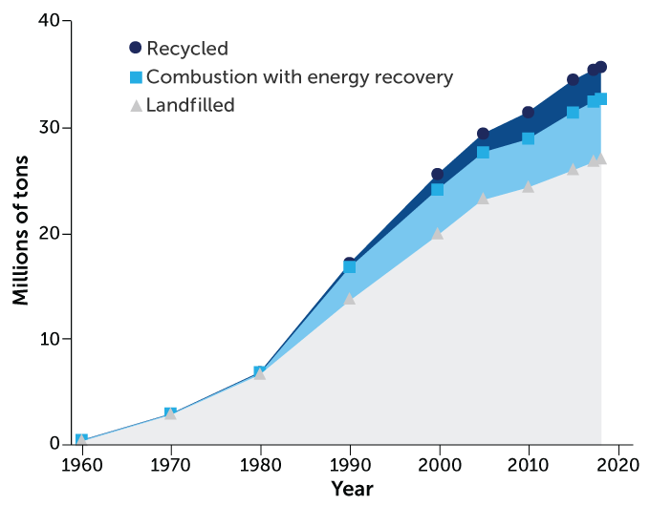E. OTWELL
SOURCE: EPA

With plastic collecting everywhere from the top of Mount Everest []to the bottom of the Mariana Trench[], there’s an urgent need to reduce the amount of plastic that gets thrown away (SN: 1/16/21, p. 5). Some people propose replacing plastics with biodegradable materials, but those replacements are generally not as strong or cheap to make as plastics (SN: 6/22/19, p. 18). Since, realistically, plastic is not going away any time soon, chemists who understand the ins and outs of all this pesky []plastic are working to make it easier to recycle and turn into higher-quality material that’s useful for more things.

“There’s not going to be a single technology that’s going to be the answer,” says Ed Daniels, senior project manager at the REMADE Institute in West Henrietta, N.Y., which funds research into new recycling techniques. Some projects are on the brink of breaking into industry; others are still just promising lab experiments. But all are focused on designing a future where any plastic that ends up in the recycling bin can have a second and third life in a new product.
窗体底端

Picking plastics apart
One of the biggest bottlenecks in plastic recycling is that every material has to get processed separately. “Most plastics are like oil and water,” says chemist Geoffrey Coates of Cornell University. They just don’t mix. Take, for example, a polyethylene detergent jug and its polypropylene cap. “If you melt those down, and I make a bottle out of that, and I squeeze it, it would basically crack down the side,” Coates says. “It’s crazy brittle. Totally worthless.”

That’s why the first destination for plastic recyclables is a material recovery facility, where people and machines do the sorting. Separated plastics can then be washed, shredded, melted and remolded. The system works well for simple items like soda bottles and milk jugs. But not for items like deodorant []containers — where the bottle, crank and cap could all be made of different kinds of plastic. Food packaging films that contain several layers of different plastic are particularly tricky to take apart. Every year, 100 million tons of these multilayer films are produced worldwide. When thrown away, those plastics go to landfills, says chemical engineer George Huber of the University of Wisconsin–Madison.

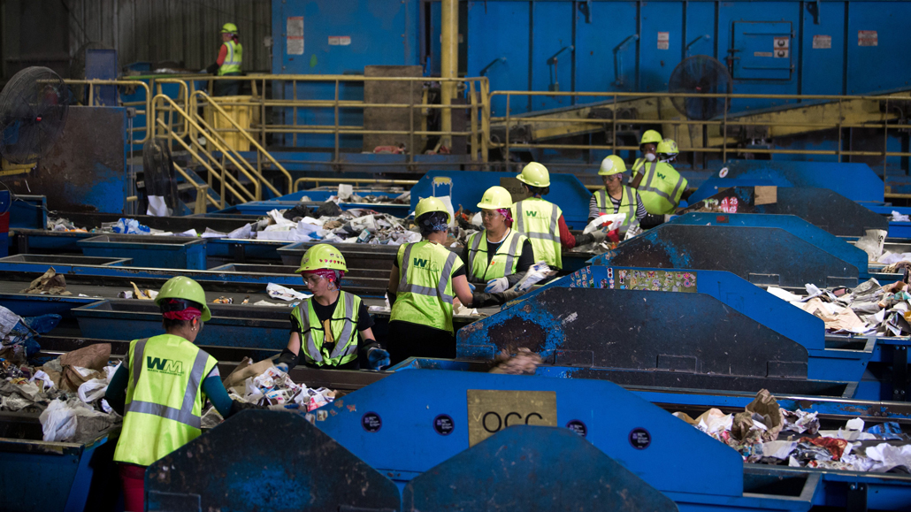At the Waste Management Material Recovery Facility in Elkridge, Md., workers sort trash moving past them on conveyor belts. SAUL LOEB/AFP VIA GETTY IMAGES

To tackle that problem, Huber and colleagues devised a strategy for dealing with complex mixtures of plastics. The process uses a series of liquid solvents to dissolve individual plastic components off a product. The trick is choosing the right solvents to dissolve only one kind of plastic at a time, Huber says.

The team tested the technique on a packaging film that contained polyethylene and PET, as well as a plastic oxygen barrier made of ethylene vinyl alcohol[], or EVOH, that keeps food fresh.

Stirring the film into a toluene[] solvent first dissolved the polyethylene layer. Dunking the remaining EVOH-PET film in a solvent called DMSO[] stripped off the EVOH. The researchers then plucked out the remaining PET film and recovered the other two plastics from their separate solvents by mixing in “antisolvent” chemicals. Those chemicals caused the plastic molecules that were dispersed in the liquids to bunch together into solid clumps that could be fished out.

This process recovered practically all of the plastic from the original film, the researchers reported last November in Science Advances. When tested on a jumble of polyethylene, PET and EVOH beads, the solvent washes recovered more than 95 percent of each material — hinting that these solvents could be used to strip plastic components off bulkier items than packaging films. So in theory, recovery facilities could use this technique to disassemble multiplastic deodorant containers and other products of various shapes and sizes.

Huber and colleagues next plan to look for solvents to dissolve more kinds of plastic, such as the polystyrene []in Styrofoam[] . But it will take a lot more work to make this strategy efficient at sorting all the intricate plastic combinations in real-world recyclables.

False advertising
Many plastic products are labeled with a number inside a triangle that symbolizes recycling. Yet, only plastics with 1 (polyethylene terephthalate) or 2 (high-density polyethylene) are widely recycled in the United States. The rest typically go to the landfill.
PET
Water and soft drink bottles, salad domes, cookie trays, salad dressing and peanut butter containers
HDPE
Milk and juice bottles, freezer bags, shampoo and detergent bottles
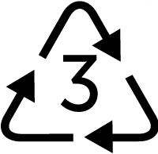PVC
Cosmetic containers, commercial cling wrap保鲜膜

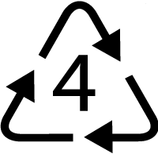LDPE
Squeeze bottles, cling wrap, trash bags
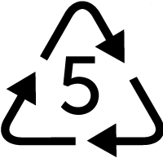PP
Microwave dishes, ice cream tubs, yogurt containers, detergent bottle caps
PS
CD cases, plastic disposable cups, plastic cutlery, video cases
EPS
Foam polystyrene hot drink cups, food takeaway trays, protective packaging for fragile items
Other
Water cooler bottles, flexible films, multimaterial packaging
SOURCE: ELLEN MACARTHUR FOUNDATION 2017

Making plastics mix
There may also be chemical shortcuts that allow multilayer films and other mixtures of plastics to be recycled as they are. Additives called compatibilizers[] help different melted-down plastics blend, so that unsorted materials can be treated as one. But there is no universal compatibilizer that allows every kind of plastic to be mixed together. And existing compatibilizers are not widely used because they are not very potent — and adding a lot of compatibilizer to a plastic blend gets expensive.

To boost viability, Coates and colleagues created a highly potent compatibilizer for polyethylene and polypropylene. Together, those two plastics make up more than half of the world’s plastic. The new compatibilizer molecule contains two segments of polyethylene, interspersed with two segments of polypropylene. Those alternating segments latch onto plastic molecules of the same kind in a mixture, bringing polyethylene and polypropylene together. It’s as if polyethylene were made of Legos, and polypropylene were made of Duplos, and the researchers made a special building block with connectors that fit both types of blocks.

Having two polyethylene and two polypropylene connectors for each compatibilizer molecule, rather than one, made this compatibilizer stronger than previous versions, Coates and colleagues reported in 2017 in Science. The first test of the new compatibilizer involved welding together strips of polyethylene and polypropylene. Ordinarily, the two materials easily peel apart. But with a layer of compatibilizer between them, the plastic strips broke, rather than the compatibilizer seal, when pulled apart.

In a second test, the researchers mixed the compatibilizer into a melted blend of polyethylene and polypropylene. It took only 1 percent compatibilizer to create a tough new plastic.

“These are crazy potent additives,” Coates says. Other compatibilizers had to be added at concentrations up to 10 percent to hold these two plastics together. The new compatibilizer is now the basis for Coates’ start-up, Intermix Performance Materials, based in Ithaca, N.Y.

Good as new
Even if every piece of plastic trash could easily be recycled, that still wouldn’t solve the world’s plastic problem. There are a couple major issues with how recycling currently works that severely limit the usability of recycled materials.

For one thing, recycled plastics inherit all the dyes, flame retardants and other additives that gave each original plastic piece its distinctive look and feel. “The plastic that you actually recover at the end of all this is really a very complex mixture,” says chemist Susannah Scott of the University of California, Santa Barbara. Few manufacturers can use plastic with a random mishmash []of properties to make something new.

Plus, recycling breaks some of the chemical bonds in plastic molecules, affecting the strength and consistency of the material. Melting down and remolding plastic is sort of like reheating pizza in the microwave — you get out basically what you put in, just not as good. That limits the number of times plastic can be recycled before it has to be landfilled.

The solution to both problems could lie in a new kind of recycling process, called chemical recycling, which promises to make pure new plastic an infinite number of times. Chemical recycling involves taking plastics apart on the molecular level.

The molecules that make up plastics are called polymers, which are made of smaller monomers[]. Using heat and chemicals, it is possible to disassemble polymers into monomers, separate those building blocks from dyes and other contaminants, and piece the monomers back together into good-as-new plastic.

“Chemical recycling has really started to emerge as a force, I would say, within the last three or four years,” says University of Pittsburgh’s Beckman. But most chemical recycling techniques are too expensive or energy intensive for commercial use. “It’s not ready for prime time,” he says.

Different plastics require different chemical recycling processes, and some break down more easily than others. “The one that’s farthest along is PET,” Beckman says. “That polymer happens to be easy to take apart.” Several companies are developing methods to chemically recycle PET, including the French company Carbios.

Carbios is testing enzymes produced by microorganisms to break down PET. Researchers at the company described their work on one such enzyme last April in Nature. Microbes normally use the enzyme, called leaf-branch compost[] cutinase[], to decompose the waxy coating on plant leaves. But the cutinase is also good at breaking PET down into its monomers: ethylene glycol[] and terephthalic acid[] .

Microbial help
An enzyme naturally produced by microbes broke down about 50 percent of polyethylene terephthalate, or PET (blue line). A tweaked version of the enzyme broke down more than 80 percent of the plastic (black dotted line). Increasing the amount of the enzyme from 1 milligram per gram of PET to 3 milligrams made it even more efficient — breaking down about 90 percent of PET.

PET breakdown by an enzyme
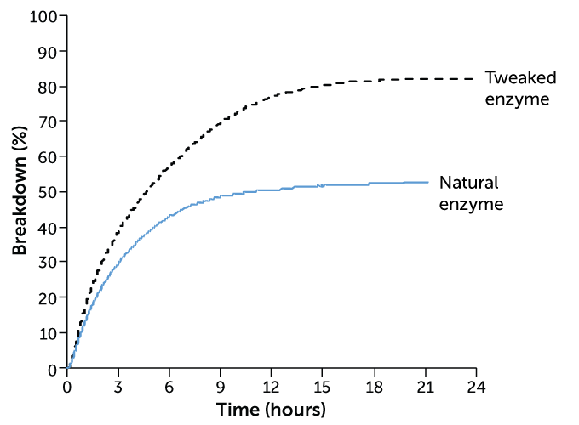E. OTWELL
SOURCE: V. TOURNIER ET AL/NATURE 2020

“The enzyme is like a molecular scissor,” says Alain Marty, chief scientific officer at Carbios. But because it evolved to decompose plant matter, not plastic, it’s not perfect. To make the enzyme better at snipping apart PET, “we redesigned what we call the active site of the enzyme,” Marty says. This involved swapping out some of the amino acids[]along that PET docking site for others.

When the researchers tested their mutant enzyme on colored plastic flakes from PET bottles, applying 3 milligrams of the enzyme per gram of PET, about 90 percent of the plastic broke down in about 10 hours. The original enzyme had maxed out at about 50 percent. Using the terephthalic acid monomers produced in that process, the researchers made new plastic bottles that were just as strong as the originals.
Carbios is now building a plant near Lyon, France, to start chemically recycling PET later this year.

Milder conditions
But other plastics, like polyethylene and polypropylene, are much harder to break down via chemical recycling. Taking apart polyethylene molecules, for instance, requires temperatures over 400° Celsius. At such high heat, the chemistry is chaotic. Plastic molecules break down randomly, generating a complex mixture of compounds that can be burned as fuel but not used to make new materials.

Scott, the UC Santa Barbara chemist, proposes partially breaking down these sturdy plastics in a more controlled way, under milder conditions, to make other kinds of useful molecules. She and colleagues recently came up with a way to transform polyethylene into alkylaromatic[]compounds, which can be used as biodegradable ingredients in shampoos, detergents and other products. The process involves placing polyethylene inside a reaction chamber set to 280° C, with a catalyst powder containing platinum nanoparticles[].
.
Polyethylene is a long molecule, in which hydrogen atoms are connected to a carbon backbone that can be thousands of carbon atoms long. The platinum is good at breaking carbon-hydrogen bonds, Scott says. “When you do that, you generate hydrogen in the reactor, and the platinum catalyst can use the hydrogen to break the carbon-carbon bonds [in the molecule backbone]. So it actually chops the chain into smaller pieces.”

Since this reaction takes place at a relatively mild 280° C, it happens in an orderly fashion, snapping long polyethylene molecules into shorter chains that are each about 30 carbons long. Those fragments then arrange themselves into the six-sided ring structures characteristic of alkylaromatic compounds.

After 24 hours in the reaction chamber, “most of the products are liquids, and most of the liquids are alkylaromatics,” Scott says. In experiments, about 69 percent of the plastic in a low-density polyethylene bag was converted into liquid. About 55 percent of a high-density polyethylene bottle cap was transformed. The process produces hydrocarbon gases too, which could be used to generate heat to run the reaction at a recycling plant, Scott says.

For now, this is just a lab demo, and like many new recycling strategies, it’s still a long way off from commercialization. And no single upgrade to the recycling pipeline will rid the world of its growing mountains of plastic trash. “We’re going to need a suite of technologies to meet this challenge,” says Daniels, of the REMADE Institute. But each new technology — whether it’s focused on making plastics easier to recycle, or transforming them into more useful materials — could help.

Built to last
The plastics produced today were never designed to be used more than once. That’s why recycling plastics — particularly into material that is as good as new — is so difficult. But researchers are going back to the drawing board to ask themselves, “What does the next generation of materials look like? How do you design a material specifically so that it never has to go into a landfill?” says Eric Beckman, a chemical engineer at the University of Pittsburgh. “Chemists are looking at whether you can design a polymer that falls apart on command.”

The development of a class of next-gen polymers, called PDKs, for poly(diketoenamine)s[], was reported in Nature Chemistry in 2019. “PDKs have the ability to break their bonds under relatively mild conditions — certainly with much lower energy intensity than any of the plastics that are currently used today,” says study coauthor Brett Helms, a chemist at the Lawrence Berkeley National Laboratory in California. Simply dunking the plastic in an acid solution with a pH of 1 or 2 is enough to break the bonds between its monomer building blocks.

“Materials don’t usually encounter a pH that’s that low, so it’s not like if you put PDKs in vinegar, the polymer is going to start breaking down,” Helms says. But it could make for easy recycling. The PDK monomers can then be used to make pristine new plastic, again and again.

Widespread plastics like polyethylene terephthalate, or PET, and polyethylene are so cheap to make that any breakout polymer would have a tough time entering the market, Beckman says. So for now, inherently recyclable plastic is just an academic curiosity. But maybe, decades from now, plastics made to be recyclable from the get-go will help solve the world’s plastic waste problem. — Maria Temming

A version of this article appears in the January 30, 2021 issue of Science News.

CITATIONS
R. Geyer, J.R. Jambeck and K.L. Law. Production, use, and fate of all plastics ever made. Science Advances, Published online July 19 2017. doi: 10.1126/sciadv.1700782.
F. Zhang et al. Polyethylene upcycling to long-chain alkylaromatics by tandem hydrogenolysis/aromatization. Science, Vol. 370, October 23, 2020, p. 437. doi: 10.1126/science.abc5441.
J.M. Eagan et a. Combining polyethylene and polypropylene: Enhanced performance with PE/iPP multiblock polymers. Science, Vol. 355, February 24, 2017, p. 814. doi: 10.1126/science.aah5744.
P.R. Christensen. Closed-loop recycling of plastics enabled by dynamic covalent diketoenamine bonds. Nature Chemistry. Vol. 11, May 2019, p. 442. doi: 10.1038/s41557-019-0249-2.
R. Geyer, J.R. Jambeck and K.L. Law. Production, use, and fate of all plastics ever made. Science Advances, Published online July 19 2017. doi: 10.1126/sciadv.1700782.
T.W. Walker et al. Recycling of multilayer plastic packaging materials by solvent-targeted recovery and precipitation. Science Advances, Published online November 20, 2020. doi: 10.1126/sciadv.aba7599.
V. Tournier et al. An engineered PET depolymerase to break down and recycle plastic bottles. Nature, Vol. 580, April 9, 2020, p. 216. doi: 10.1038/s41586-020-2149-4.


About Maria Temming
Maria Temming is the staff reporter for physical sciences, covering everything from chemistry to computer science and cosmology. She has bachelor's degrees in physics and English, and a master's in science writing.

Related Stories
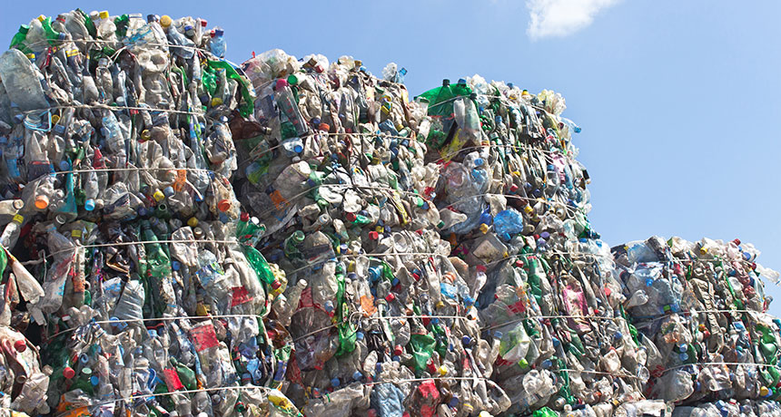
ENVIRONMENT

This plastic can be recycled over and over and over again

By Laurel HamersApril 26, 2018


MATERIALS SCIENCE

Recyclable superplastics made with old chemistry

By Beth MoleMay 15, 2014

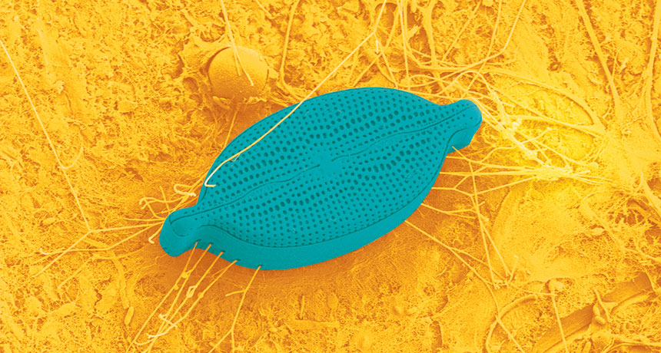
EARTH

Ocean’s plastics offer a floating fortress to a mess of microbes

By Chris SamorayFebruary 9, 2016

[] [ˌpɒliˈprəʊpəliːn] [高分子] 聚丙烯
[] [ˈhɒdʒpɑːdʒ] n.烩；混煮；一团糟
[] [teref'θæleit]n. 对苯二酸盐；对苯二酸酯
[] 聚对苯二甲酸乙二醇酯
[] 埃佛勒斯峰, 喜马拉雅山主峰之一，中国称珠穆朗玛峰
[] 马里亚纳海沟（太平洋海底）
[] adj. 讨厌的，麻烦的
[] adj. 除臭的，防臭的
[] 乙烯乙烯醇
[] 甲苯
[] 二甲基亚砜
[] 聚苯乙烯
[] 泡沫聚苯乙烯
[] n. [助剂] 增容剂
[] n. 混杂物
[] 单体
[] 堆肥；混合物
[] 角质酶
[] 乙二醇
[] 对苯二甲酸
[] [生化] 氨基酸
[] 烷基芳烃的
[] 铂纳米颗粒
[] 聚二酮烯胺

